Hands-on Lab: Get to know Cloudant

**Estimated time needed:** 30 minutes

Lab Overview

In this hands-on lab, you will get to know the Cloudant database service. We'll start by creating an instance of the service, creating a database, creating a few documents in that database, and then run a query using the Cloudant console.

Objectives

After completing this lab, you will be able to:

1. Create a Cloudant database service.
2. Create a database in with your Cloudant service.
3. Create a document within your database.
4. Query your database using the Cloudant Console.

Lab Instructions

This lab is broken up into the following tasks:

1. [Create the service](https://cf-courses-data.s3.us.cloud-object-storage.appdomain.cloud/IBMDeveloperSkillsNetwork-CC0103EN-SkillsNetwork/labs/module-4-lab-1/index.md.html#1-create-the-service)
2. [Create a database](https://cf-courses-data.s3.us.cloud-object-storage.appdomain.cloud/IBMDeveloperSkillsNetwork-CC0103EN-SkillsNetwork/labs/module-4-lab-1/index.md.html#2-create-a-database)
3. [Create documents](https://cf-courses-data.s3.us.cloud-object-storage.appdomain.cloud/IBMDeveloperSkillsNetwork-CC0103EN-SkillsNetwork/labs/module-4-lab-1/index.md.html#3-create-documents)
4. [Query your database using the Cloudant Console](https://cf-courses-data.s3.us.cloud-object-storage.appdomain.cloud/IBMDeveloperSkillsNetwork-CC0103EN-SkillsNetwork/labs/module-4-lab-1/index.md.html#4-query-your-database-using-the-cloudant-console)

1. Create the service

Navigate to [https://cloud.ibm.com/catalog](https://cloud.ibm.com/catalog?utm_email=Email&utm_source=Nurture&utm_content=000026UJ&utm_term=10006555&utm_campaign=PLACEHOLDER&utm_id=SkillsNetwork-Courses-IBMDeveloperSkillsNetwork-CC0103EN-SkillsNetwork-19956175) to launch the IBM Cloud Catalog.

From the catalog, choose the **Services** menu on the left, and filter by **Databases** and **Lite**. Then click on the **Cloudant** tile.

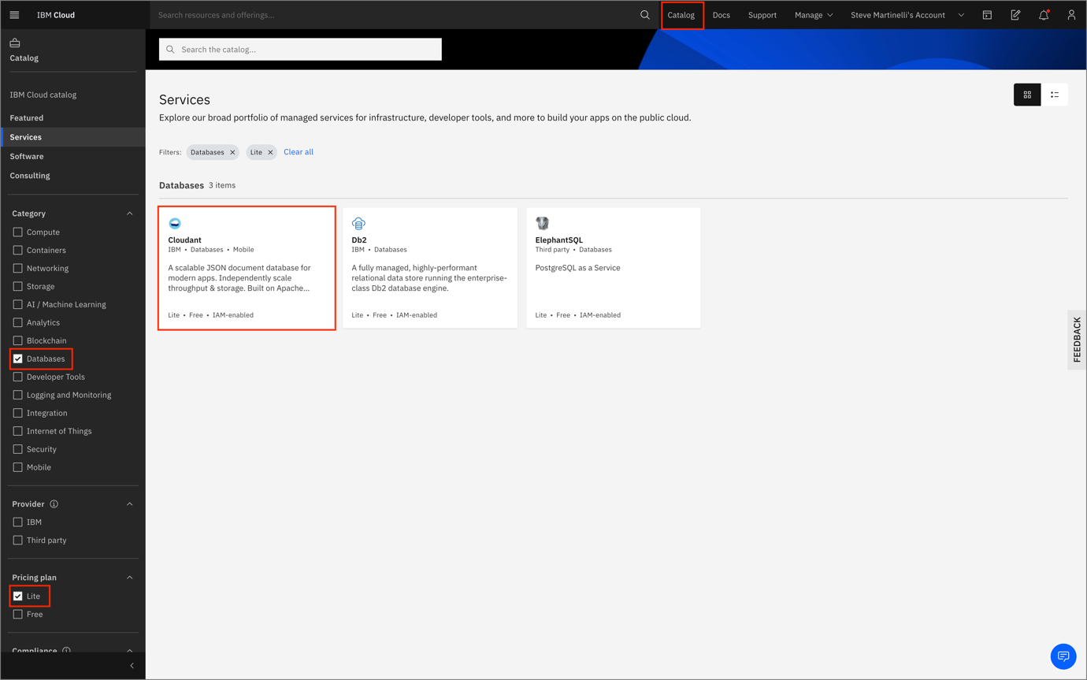

On the next screen, choose the Cloudant offering, the multitenant environment, and the Lite tier. You can optionally give your service a name. Click the **Create** button to continue.

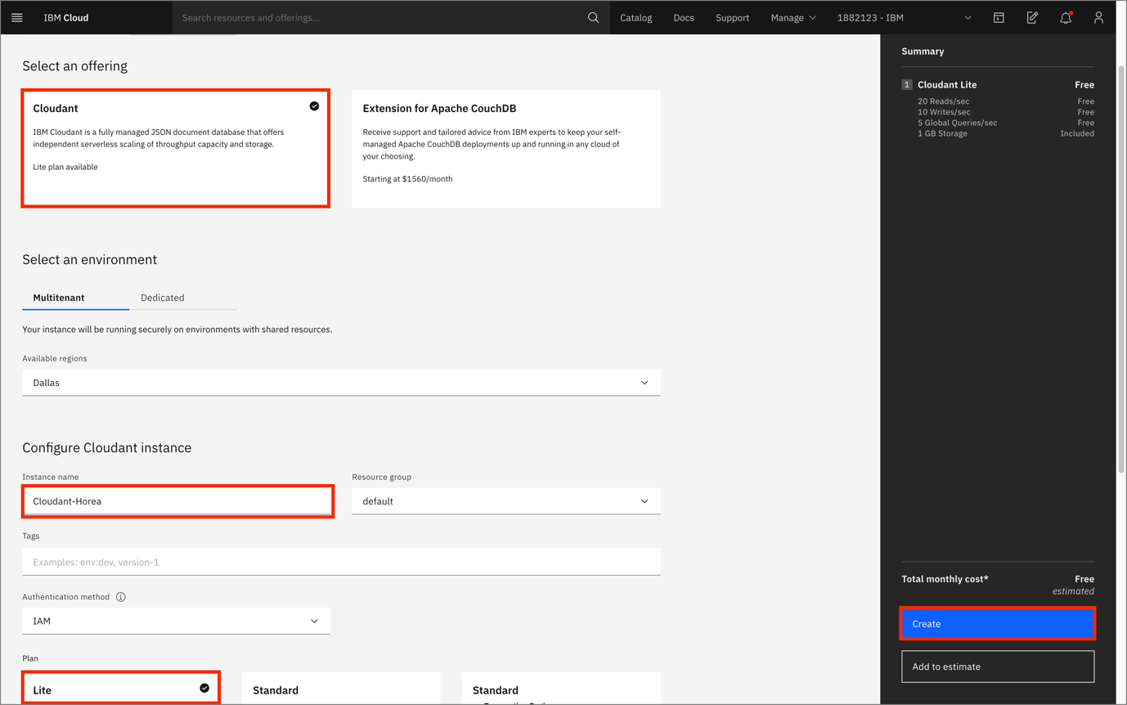

At the Cloudant overview screen, click on the **Launch Dashboard** button.

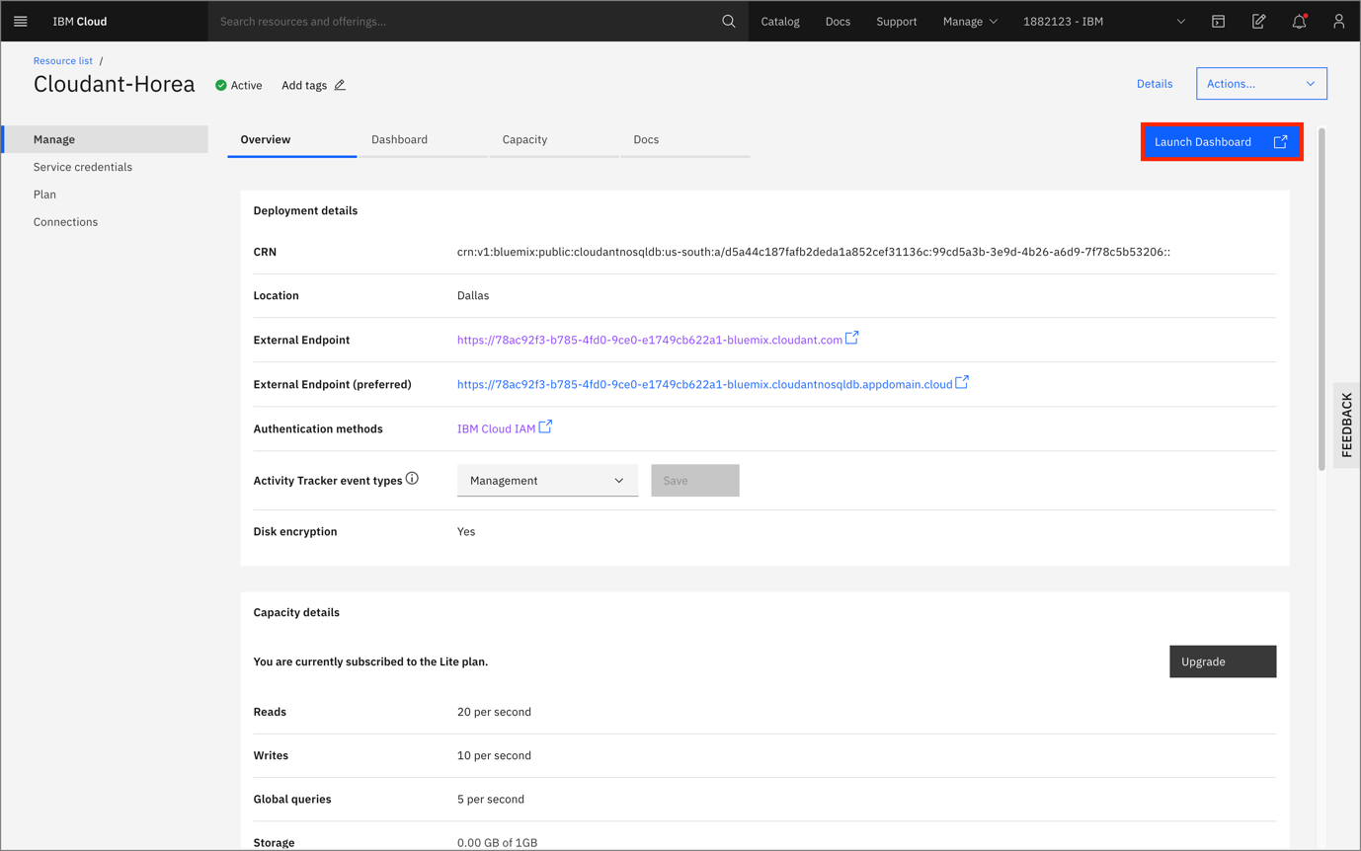

2. Create a Database

Click on the Create Database button in the top-right corner. Give your database a name, choose Non-partitioned and then click on Create.

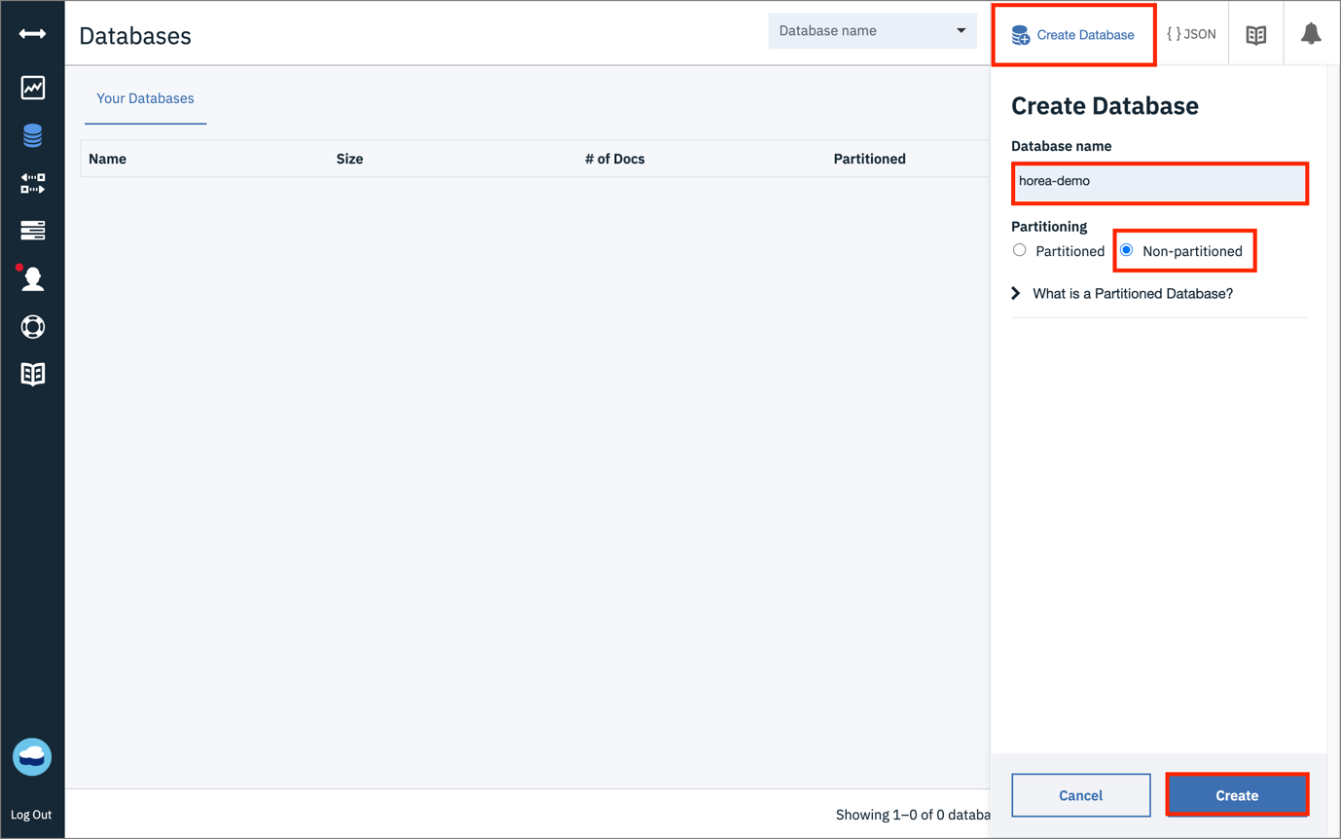

3. Create Documents

Next, click on the Create Document button in the top-right corner.

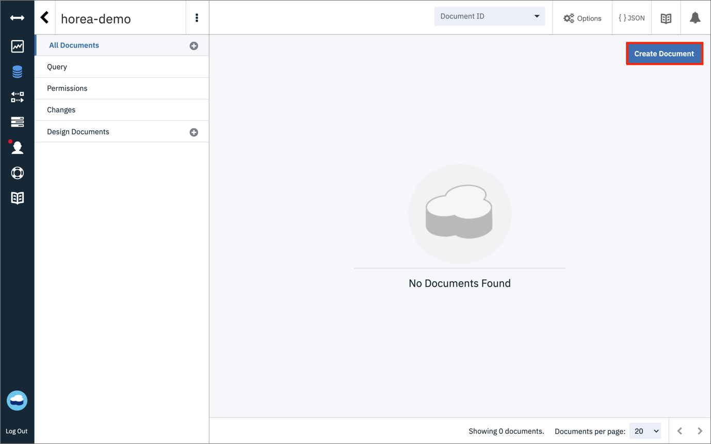

Next, you should be greeted with a document that has a JSON format with the first key value pair being

"_id": "<your_id here>"

Leave the _id field as is, but fill out two key-value pairs for "employeeNum": "123", and "salary": "50" as shown below. Once you are done, click on Create Document in the top-left corner.

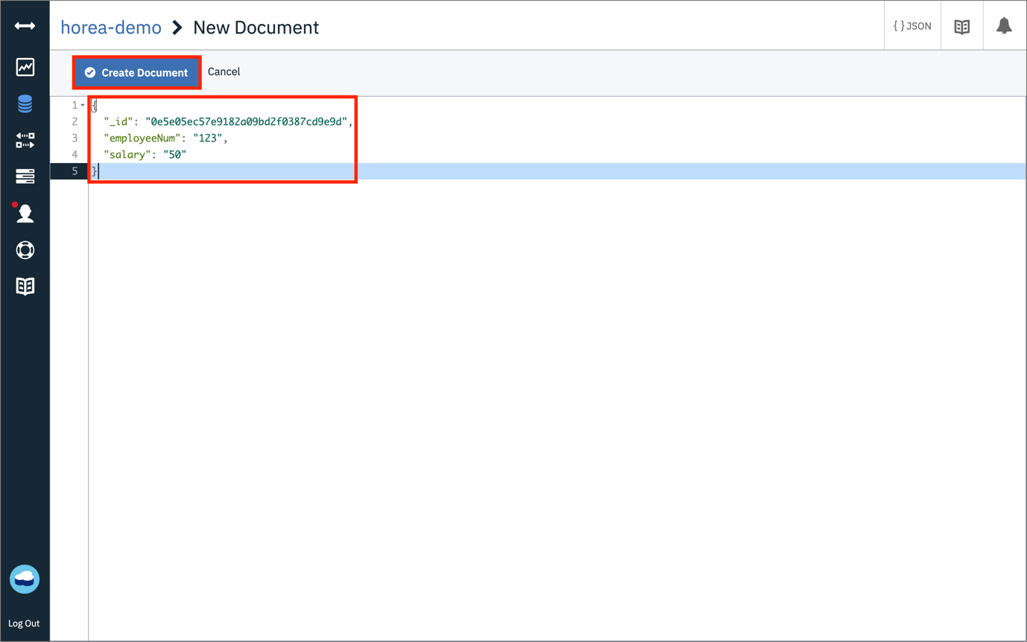

Next, replicate the process, but add in two key-value pairs for "employeeNum": "234", and "salary": "55". Create this document as well.

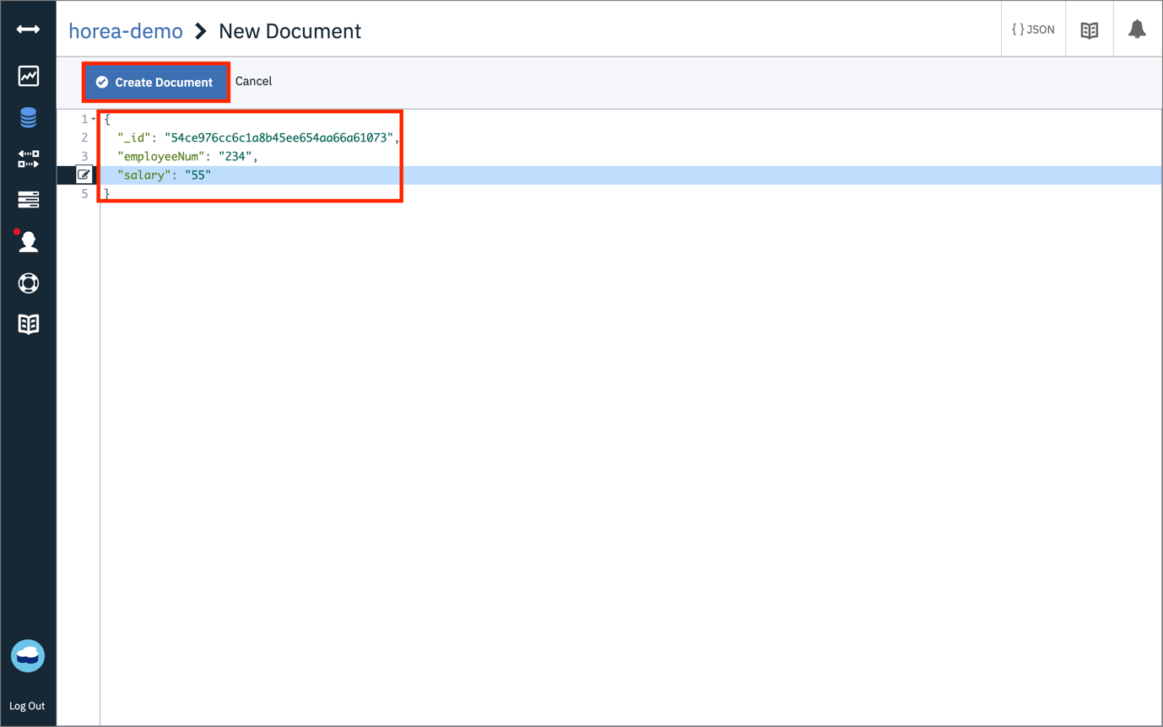

Lastly, replicate the process of creating a document again, and this time add in two key-value pairs for "employeeNum": "345", and "salary": "47".

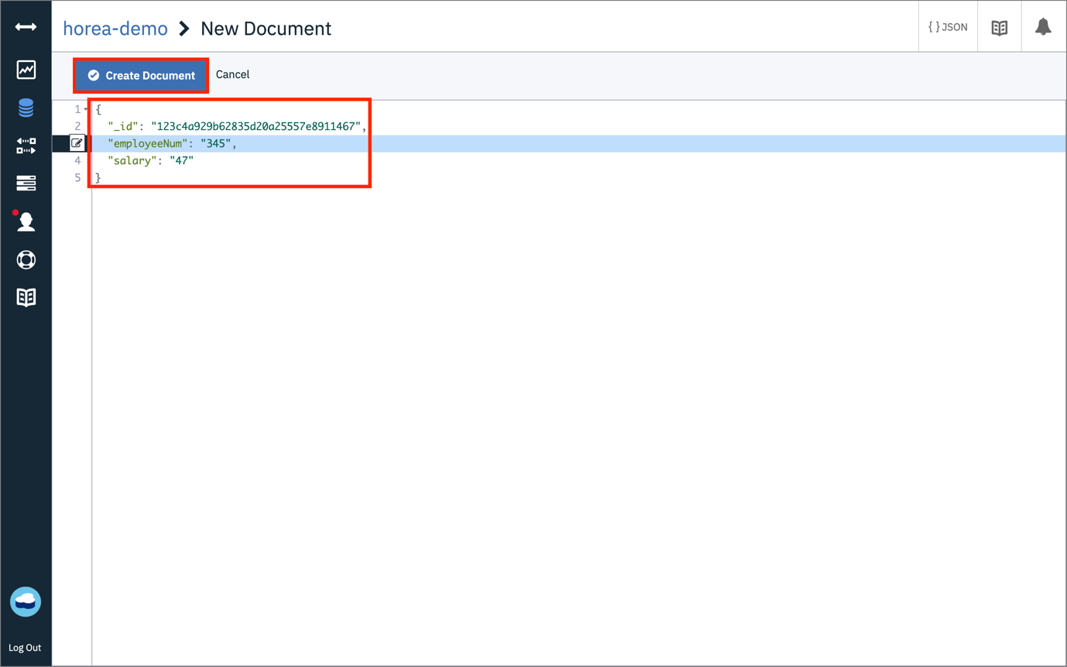

Once you are done creating the three documents, click on the Table button in the top-center of your screen. You should be able to see your three documents, with the employeeNum and salary columns as shown below.

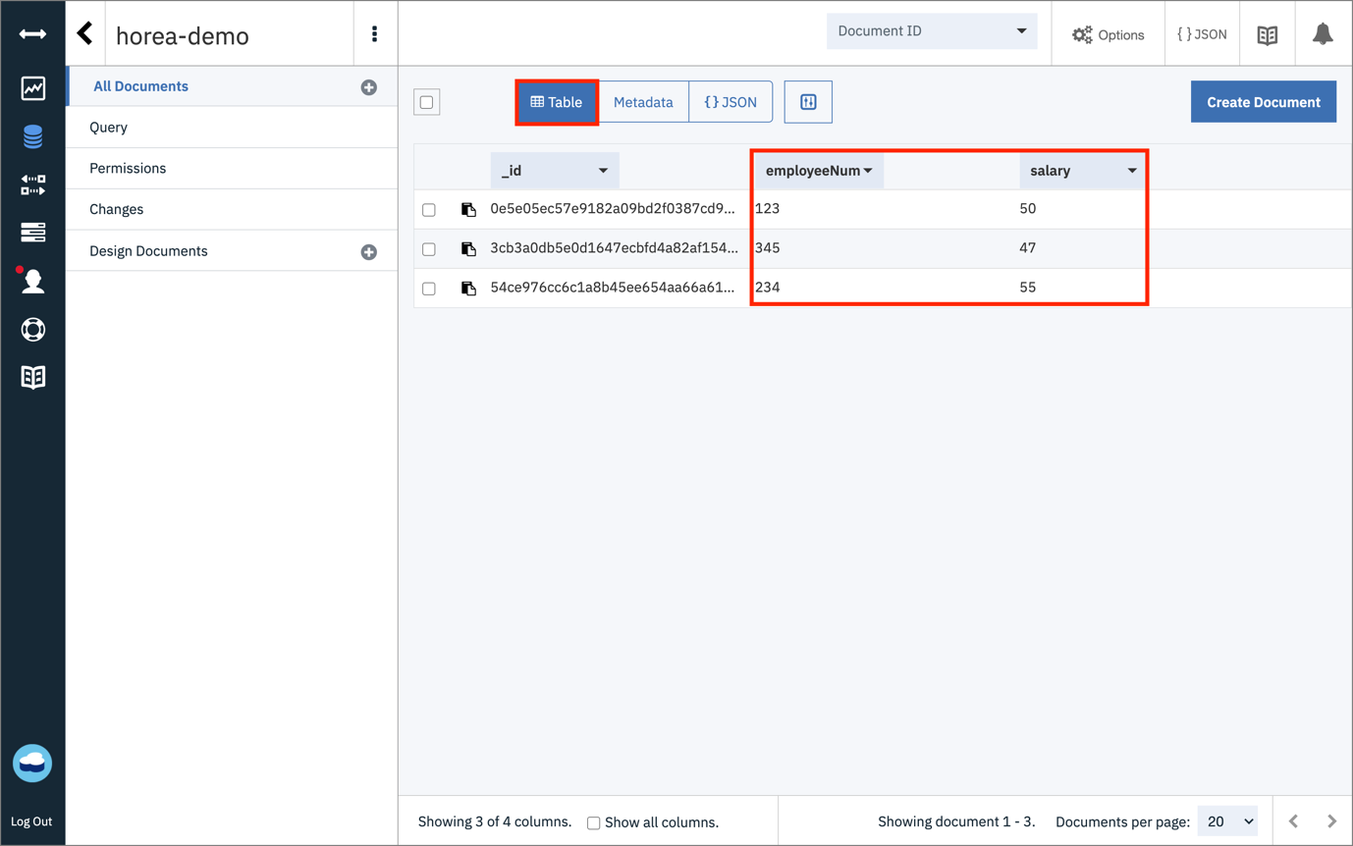

4. Query your database using the Cloudant Console

Now, let's go ahead and query our database. Click on the **Query** tab.

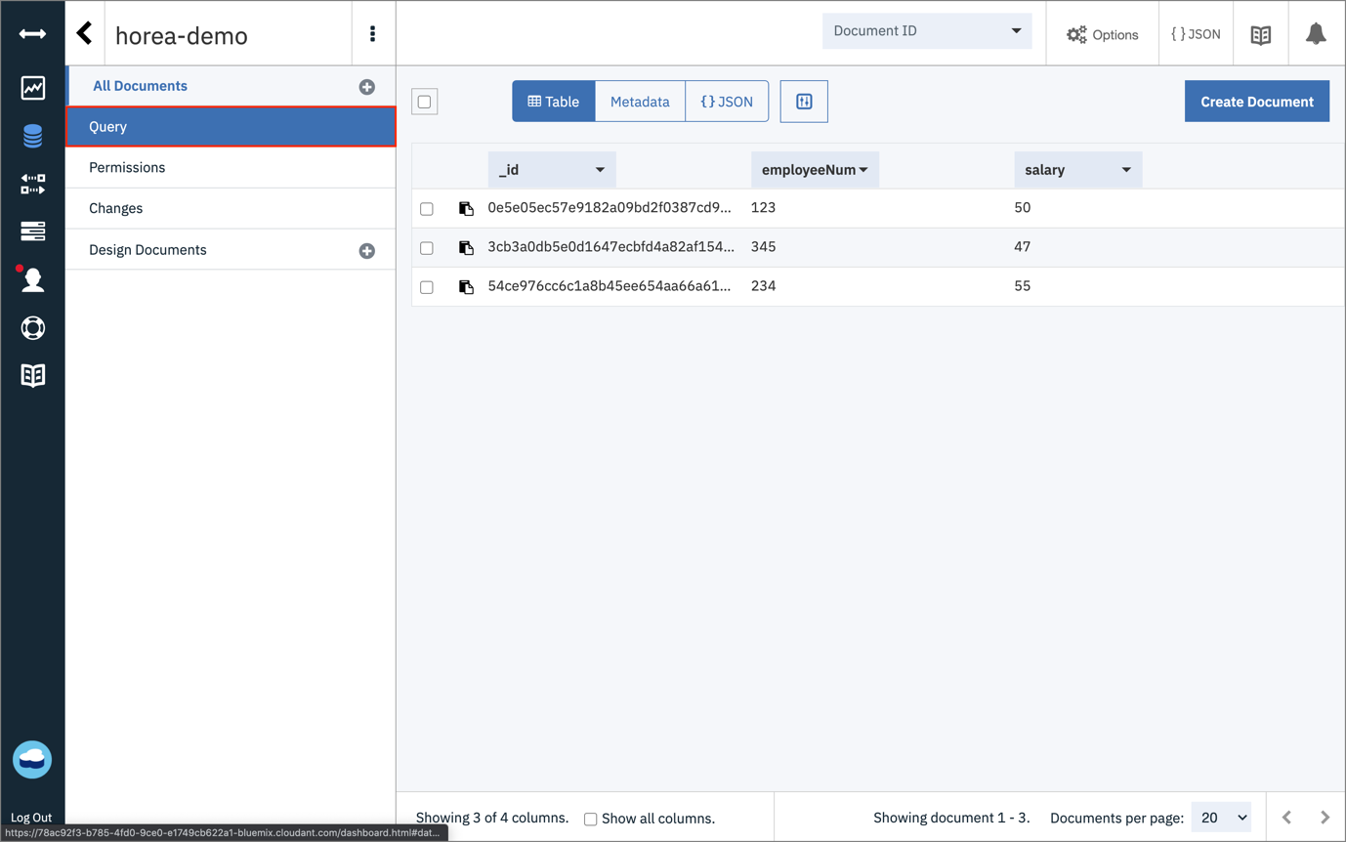

Go ahead and paste the following code in the query, which means we will find all employees, with a salary greater than 48:

{

"selector": {

"salary": {

"$gt": "48"

}

}

}

Once you are done pasting in the code, click on **Run Query**

You should see two documents, each of which have a salary field greater than 49.

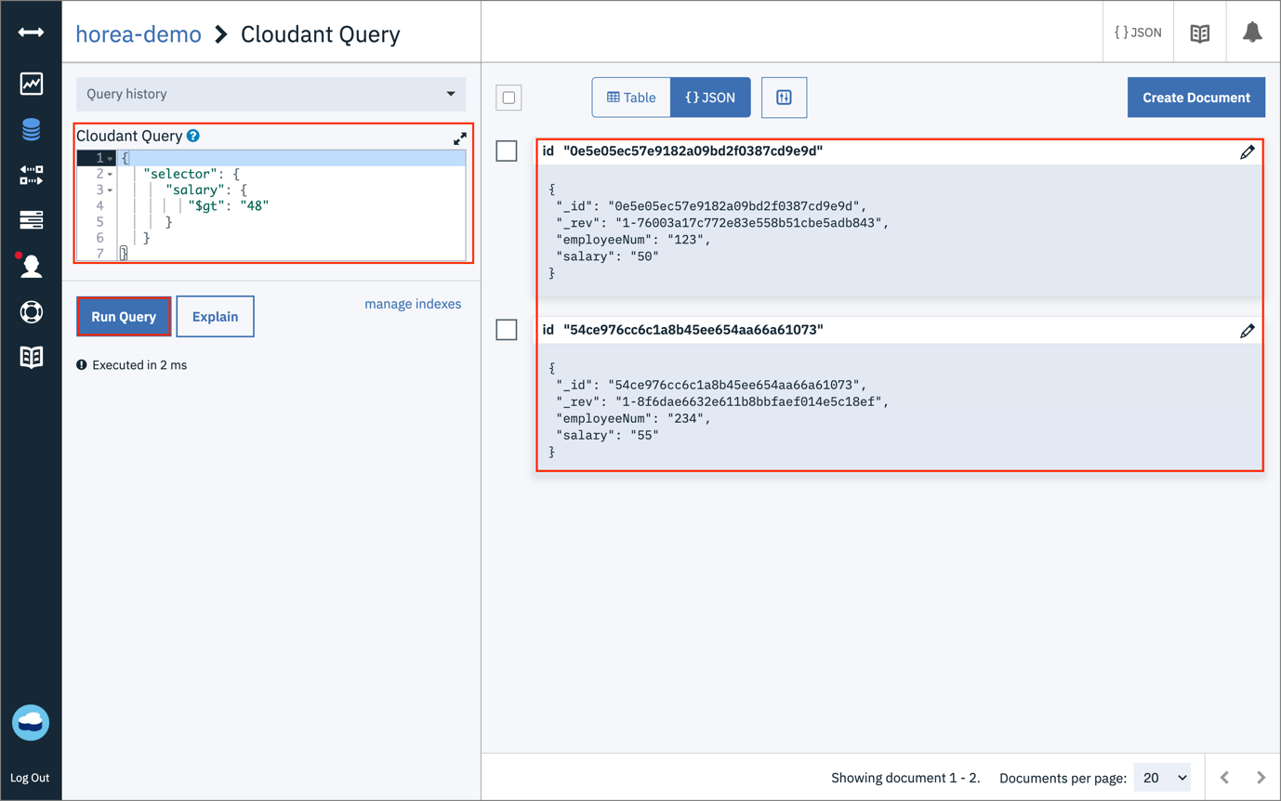

**Congratulations!** You've successfully created a Cloudant database and queried the documents!